Sample Poster or flyer
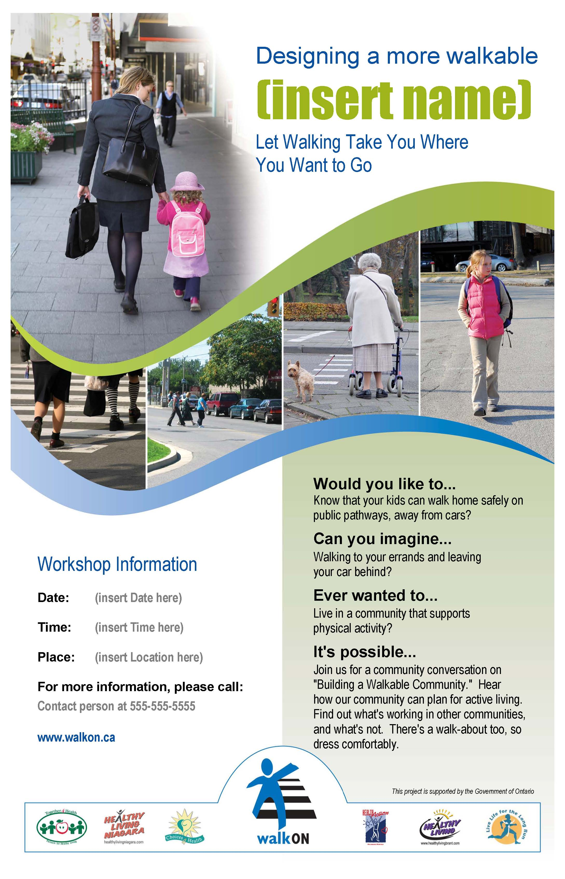
Always remember to put information on your poster or flyer to let people know what you want them to do – such as come to something, do something or contact someone – and make sure you include all the details they’ll need to do it.

