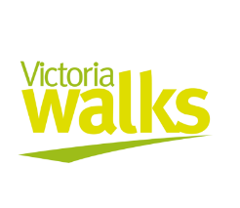
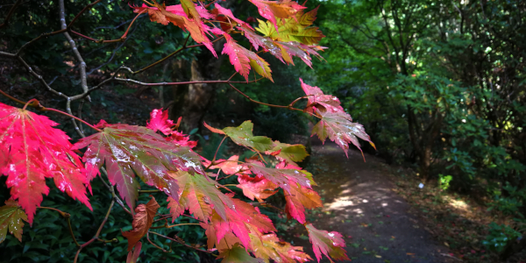
Autumn 2019 photo competition
TERMS and CONDITIONS
- The competition entry instructions form part of these terms and conditions.

- The competition commences at 12.01am AEST on Friday April 5th 2019 and finishes at 11.59pm on Sunday April 28th 2019 AEST (the “competition period”). Entries must be submitted during this period.
- Entry into this competition is open to all persons residing in Victoria aged 18+ who submit an entry during the competition period (“Eligible Entrants”).

- The Promoter is Victoria Walks Inc (No. A0052693U) ABN: 88419420305 of Level 7, 225 Bourke Street, Melbourne VIC 3000.
- Eligible Entrants will be limited to one photo entry each. Employees of the Promoter and their suppliers, or their immediate families are not eligible to enter the competition.

- By submitting a photo (the submission), the Eligible Entrant is representing to Victoria Walks that:
  - The submission is the Eligible Entrant's own work;
  - The photo is taken within Victoria;
  - The Eligible Entrant indemnifies and holds harmless Victoria Walks in the event that the submission or any part thereof is not the Eligible Entrant's own work and/or otherwise constitutes a breach of copyright; and
  - The Eligible Entrant has obtained the relevant consent required by law from any subjects that are featured in the submission for the purpose of their image to be used as set out in clause 14, without payment of fee or other consideration by Victoria Walks. Victoria Walks may direct Entrants to seek written permission from any subjects featured in their submission, and may withhold prizes from winners until this is satisfactorily completed.

- Victoria Walks reserves the right to disqualify unsuitable entries.
- Winners will be judged according to the following categories:

Category | Prizes | Value
Best Victorian Autumn photo  To be judged by staff at Victoria Walks | A $250 voucher to spend on an experience or product at Red Balloon Australia*. | $250
People’s Choice  Most ‘Liked’ photo featured in our judges’ finalists Facebook gallery as voted between 9am Thursday May 2nd and 9am Monday May 6th 2019. | A $50 Coles/Myer* voucher.  And a voucher for two adults for afternoon tea session, The Cuckoo Restaurant, Olinda, Victoria, valid until end October 2019. | Approx. $114
*Vouchers are subject to Terms and Conditions specified by voucher retailers.
Vouchers: More information
Red Balloon: https://help.redballoon.com.au/s/article/Terms-and-Conditions
Coles/Myer: https://www.giftcards.com.au/giftcardtermsofuse
Cuckoo Restaurant: Check website to see what days afternoon tea is available https://www.cuckoorestaurant.com.au/food/times-prices/ and note voucher must be used by end October 2019

- The judge’s decision is final and no correspondence will be entered into.
- The prizes must be taken as stated. No compensation will be payable if the winner is unable to use the prize as stated for whatever reason. If the prize is not taken for any reason it is forfeited.

- Competition winners will be required to show proof of age and residential status prior to any prize being given.

- The winners will be notified by email (or phone) by 5pm Monday May 6th 2019. Their names and their winning entries will be published on the Victoria Walks’ Facebook page and website on Wednesday May 8th 2019.
- In entering the competition, the Eligible Entrant grants Victoria Walks an unconditional license to publish and republish the submission or any part thereof on the Victoria Walks website or social media pages and groups or in any of its other publications. Victoria Walks may edit, use part of or quote from the story, photos or artwork in any publications or publicity materials as it sees fit.

- The Eligible Entrant agrees that no fee or other consideration will be payable by Victoria Walks for its right to use the Eligible Entrant's submission, whether in respect of a license fee or otherwise, other than the entry of the Eligible Entrant into the competition.

- Victoria Walks accepts no responsibility for late, lost or misdirected entries.

- Victoria Walks is not liable for any costs associated with the entry of the competition.

- To the extent permitted by law, the Promoter, its employees and agents shall not be liable for any claims, losses, damages, injuries, costs and expenses suffered sustained or incurred (including but not limited to indirect or consequential) as a result of, or arising out of, or in any way connected with this promotion and/or its prizes.
- Prizes are not transferable or exchangeable and cannot be taken as cash.

- No responsibility is accepted for any variation in the value of the prizes.

